***ASSIGNMENT 10***

***Student Name:Sirisha Matta***

***Student id:1794858***

***Flow chart***

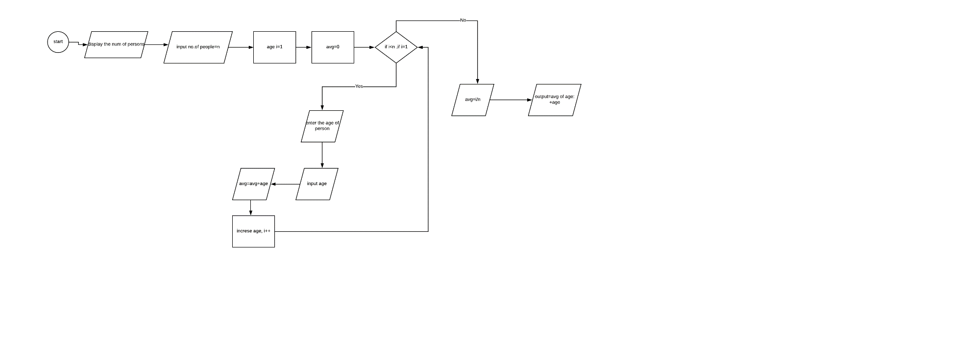

***Pseudocode***

1. Declare no.of persons
2. Declare(input num of people:i)
3. Declare avg
4. Declare age
5. Output : how many people
6. Input n
7. i = 1
8. avg = 0
9. If i=1,i<n

10.Enter the age of person

11.Input age

12.Avg = avg + age

13.I++

14.avg = i/ n

15.Output : average of age+ age

16.end

Trace 1

|  |  |  |  |  |  |  |
| --- | --- | --- | --- | --- | --- | --- |
| Line no. | Input buffer | No.of people | i | Avg | age | Output buffer |
| 1. | - | - | x | x | x | - |
| 2. | - | - | - | x | x | - |
| 3. | - | - | - | - | x | - |
| 4. | - | - | - | - | - | - |
| 5. | - | - | - | - | - | How many people |
| 6. | 4 | 4 | - | - | - | - |
| 7. | - | 4 | 1 | - | - | - |
| 8. | - | 4 | 1 | 0 | - | - |
| 9. | - | 4 | 1 | 0 | - | - |
| 10. | - | 4 | 1 | 0 | - | Enter age of person |
| 11. | - | 4 | 1 | 0 | 12 | - |
| 12. | - | 4 | 1 | 12 | 12 | - |
| 13. | - | 4 | 2 | 12 | 12 | - |
| 9. | - | 4 | 2 | 12 | - | - |
| 10. | - | 4 | 2 | 12 | - | Enter age of person |
| 11. | - | 4 | 2 | 12 | 14 | - |
| 12. | - | 4 | 2 | 26 | 14 | - |
| 13. | - | 4 | 3 | 26 | 14 | - |
| 9. | - | 4 | 3 | 26 | - | - |
| 10. | - | 4 | 3 | 26 | - | Enter age of person |
| 11. | - | 4 | 3 | 26 | 28 | - |
| 12. | - | 4 | 3 | 54 | 28 | - |
| 13. | - | 4 | 4 | 54 | 28 | - |
| 9. | - | 4 | 4 | 54 | - | - |
| 10. | - | 4 | 4 | 54 | - | Enter age of person |
| 11. | - | 4 | 4 | 54 | 28 | - |
| 12. | - | 4 | 4 | 78 | 28 | - |
| 13. | - | 4 | 5 | 78 | 28 | - |
| 14. | - | 4 | 5 | 78 | 28 | - |
| 15. | - | 4 | 5 | 28 | 28 | - |
| 16. | - | 4 | 5 | 28 | 28 | Average of age + age |